SWEETHEART
SWING
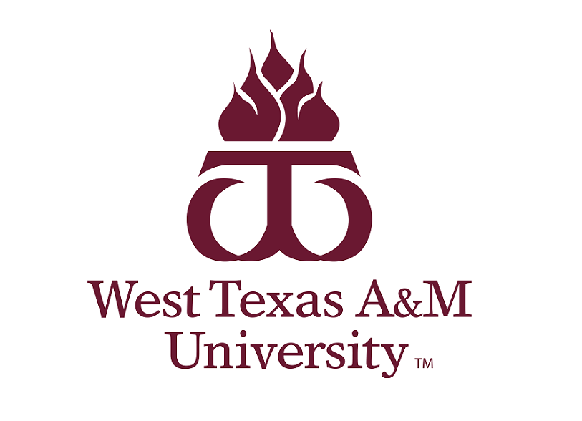
February 9th-11th 2024
Lawton, Oklahoma

Dear Forensics Community,

The forensics teams of Cameron University and West Texas A&M University are honored to invite you to this year's Sweetheart Swing, which will be hosted on the campus of Cameron University on February, 9-11, 2024.

We invite you to join us for a weekend featuring:

- 2 AFA Individual Event Tournaments
- IPDA Debate

Registration will take place on www.speechwire.com.

IPDA competitors will be able to compete in both IE tournaments.

We hope to welcome you to Lawton in February and look forward to receiving your entry by Tuesday, February 6, 2024, at 5:00 p.m.

Sincerely,

Katie Stringer
Cameron University
Kstringe@cameron.edu

Dr. Kelsey Abele
West Texas A&M
kabele@wtamu.edu
Tournament Guidelines
AFA-NIET rules will be followed in the participation and tabbing for all individual events.
Students may enter a maximum of three events per pattern. The patterns are:

Pattern A: DI, EXT, PER, POE, PRO
Pattern B: ADS, CA, DUO, IMP, INF, POI

Debate IPDA guidelines:
There will be 6 prelim rounds with up to three possible elimination rounds. We strongly encourage debaters to not enter EXT on Saturday. Note: Two Elimination rounds will be held on Saturday, debaters should be aware that entering in IE’s and Debate will be tight, and it will leave a very limited lunch.

Registration will take place on Speechwire.com. Preliminary entry is due by Tuesday, February 6, 2024 at 5:00 p.m. Drops or changes can be made until Thursday February 8, 2024.

Students should not enter material that has been used in competition before September 1, 2023.

Hosting schools reserve the right to enter students into the tournament to compete but will take themselves out of the running for Team Sweepstakes.

Any events with 8 or less students will go straight to auto finals.

Food
There is limited food on campus. (They will only be open on Friday.) There is a large amount of food locations within blocks on the campus, and a Subway located within walking distance. Feel free to ask for recommendations and we will be providing a list of locations prior to the tournament.

Fees

Individual Events: $10 (one judge covers 8 slots)
IPDA: $40 (one judge covers 2 debaters)

Miscellaneous Fees
Uncovered IE entries: Fee + $10
Uncovered IPDA entries: Fee + $40
IE Drops at tournament: Fee + $20
IPDA Drops at tournament: Fee + $20

Payment by cash, check or PO is expected at registration. CASH is preferred if possible to help pay judges.

All IE judges are expected to be available for final rounds. Debate judges are expected to be available for one round past when their teams are eliminated.

We would much rather have your judges than your money!! Please try to cover your judges as best as possible. It can be tricky to find judges here.

Awards

All IE finalists and debate elimination round contestants will receive awards.

For each IE tournament, sweepstakes awards will be given to the top 3 schools and top 3 quadrathlon speakers.

Quadrathon eligibility requires students to compete in three events and IPDA, which must include at least one interpretation event (DI, DUO, POE, POI, PRO) and one public address event (ADS, CA, INF, PER, EXT, IMP).

In debate, the top 3 speakers in each division of IPDA will receive awards. The top 3 schools will also win awards.

The top 3 overall schools in IE and debate during the swing will also be recognized, as well as, the top community college and top program from Oklahoma. To calculate overall team awards, the percentage of total points earned in IE’s plus the percentage of total points earned in debate will be utilized as the determining factor in ranking these programs.

Sweepstakes
Prelim points 1=3 debate win =4
2=1

Final placing for all 1=8. 2=7, 3=6, 4=5, 5=4, 6=3

Tentative Schedule for Tournament

Friday, February 9, 2024
8:00 - 8:30 a.m. Registration
8:30 a.m. IPDA Draw/Round 1
10:00 a.m. IPDA Draw/Round 2
11:30 a.m. IPDA Draw/Round 3
Lunch Break
1:30 p.m. IPDA Draw/Round 4
3:00 p.m. IPDA Draw/Round 5
4:30 p.m. IPDA Draw/Round 6
6:00 p.m. IPDA Draw/Elimination round 1

Saturday, February 10, 2024
7:30 - 8:30 a.m. I.E. Registration
7:30 a.m. IPDA Draw/ Elimination Round 2
8:30 a.m. Extemp draw
9:00 a.m. Round 1 (Pattern A)
10:15 a.m. Round 1 (Pattern B)
11:30 a.m. Round 2 (Pattern B)
Lunch Break
1:00 p.m. IPDA Draw/Elimination Round 3
1:45 p.m. Draw
2:00 p.m. Round 2 (Pattern A)
3:15 p.m. Finals (Pattern B)
4:30 p.m. Draw
4:45 p.m. Finals (Pattern A)
AWARDS ASAP
*Will collapse finals to one round if possible*

Sunday, February 11, 2024
7:30- 8 a.m. IE registration
8:00 a.m. Extemp draw
8:30 a.m. Round 1 (Pattern A)
10:00 a.m. Round 1 (Pattern B)
11:30 a.m. Round 2 (Pattern B)
Lunch Break
1:15 p.m. Draw
1:45 p.m. Round 2 (Pattern A)
3:00 p.m. Finals (Pattern B)
4:15 p.m. Draw
4:30 p.m. Finals (Pattern A)
AWARDS ASAP
*Will collapse finals to one round if possible*

